Extra Practice 2
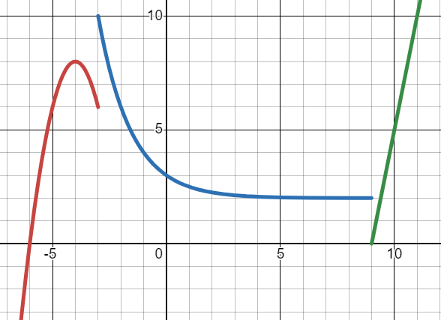
(1) Write equation of a piecewise function
Graph of $y=f(x)$
a). Write the equation for each piece separately first.
Parabolic part:
Transformation of $2^{x}$:
Linear part:
b). Now together as a piecewise defined function.

(2). Evaluate a piecewise function.
$$f\left(x\right)=\left\{\begin{aligned}-3(x-1), x≤0 \\ \frac{1}{x}, 0<x<1 \\ \begin{matrix}3, 1<x<3 \\ \sqrt{4-x}, 3≤x\end{matrix}\end{aligned}\right.$$

a). f(2) b). $f\left(-3\right)=$ c). $f\left(1\right)=$
d). $f\left( 2f\left(0\right)-f\left(\frac{1}{2}\right) \right)=$

(3).
a). Use point-slope form to write the equation of a line with a slope of $\frac{4}{5}$ that goes through the point (-35, 45).
b). Use point-slope form to write the equation of a line that goes through (103, 46) and (113, 45).

4). Use $x(t)$ and $y(t)$ to plot the path from $0≤t≤4$.
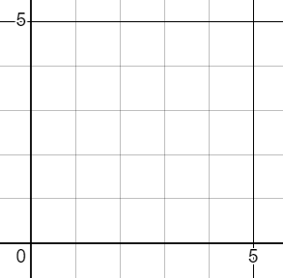
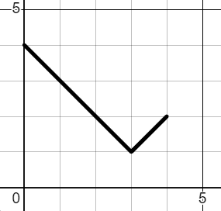
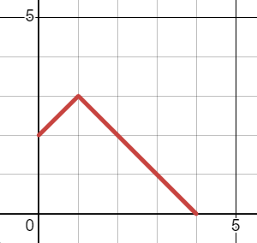
Label time information and direction arrows for the motion
path
X
Y
x(t)
y(t)
t
t
Y
X

5). For $t≥0$ a motion along a path is defined by $x\left(t\right)={-\left(t-3\right)}^{2}+4$ and $y\left(t\right)=10-2t$
a). During what time interval(s) is the horizontal movement of the point from right to left ?
b). Does the path ever cross the x-axis? If so, what are the coordinates of the x-intercept? If not, how do you know?

6). A student is trying to make a parameterization of $y=x^{3}$ so that the x-coordinate increases as a rate faster than 1 unit per second.
They write $x\left(t\right)=3t$ but they aren’t sure if they should write $y\left(t\right)=t^{3}$ or $y\left(t\right)=3⋅t^{3}$ or something else? They ask: “if I do something to t in the x equation, do I also need to do it in the y equation?”
Give the best teacher-answer you can to that question. It should help the student understand how parametric equations work.

7). Find the cartesian equation for the path traversed by each set of parametric equations
a). $x\left(t\right)=t-10$ $y\left(t\right)=t^{2}+t$
b). $x\left(t\right)=\sqrt[3]{\frac{t}{2}+1}$ $y\left(t\right)=t\sqrt{t-1}$
c). $x\left(t\right)=\sqrt{\frac{\sin\left(t\right)}{2}}$ $y\left(t\right)=\frac{1}{3 - sin(t)}$

8).
a). Create $x(t)$ and $y(t)$ so that a point begins at (3, 2) at t = 5, and moves at a constant speed along a linear path to the location (10, 1) by t = 10.
b). As you remember, $x\left(t\right)=t^{2}$ and $y\left(t\right)=t^{2}$ for $t≥0$ represents the linear path $y=x$, but with a motion that accelerates. Can you create movement along $y=x$ but with a motion that decelerates? (slows as time increases).
c). Can you create movement along the linear path $y=\frac{1}{2}x+4$ that starts at $(100, 54)$ at $t=0$, moves left and accelerates as time increases?

9).
a). Sketch the path and motion defined by $x\left(t\right)=cos\left(π+t\right)$ and $y\left(t\right)=5+2\sin\left(π+t\right)$. Show where $t=0$ is and draw arrows indicating the direction of motion.
b). What if we modify part a to be: $x\left(t\right)=cos\left(\frac{π}{t}\right)$ and $y\left(t\right)=5+2\sin\left(\frac{π}{t}\right)$ with the restriction that $t≥1$. What can you say about the movement?
b). Define an x(t) and y(t) so a point moves clockwise around a circle radius 3 centered at the point (-3, 4).
At t = 0 it should be at (-3, 7). At t = 3 it should be at (-3, 1).
10).
a). Create an x(t), y(t) parameterization for $y=x^{2}-2$ where the point moves from right to left as time increases.
b). Create an x(t) and y(t) so that a point moves along the curve.
$y=1+\sqrt[3]{x-2}$. At t = 0, its x-coordinate should be -10. By t = 5 it should be further than a distance of 20 from the origin.

Solutions to extra Practice 2

1). Write equation of a piecewise function
Graph of $y=f(x)$
a). Write the equation for each piece separately first:
Parabolic part: $y=-2{\left(x+4\right)}^{2}+8$
Transformation of $2^{x}$: $y=2^{-x}+2$
Linear part: $y=5\left(x-10\right)+5$
b). Now together as a piecewise defined function:
$$f\left(x\right)=\left\{\begin{aligned}-2{\left(x+4\right)}^{2}+8, x<-3 \\ 2^{-x}+2, -3<x<10 \\ \begin{matrix}5\left(x-10\right)+5, 10≤x \\ \end{matrix}\end{aligned}\right.$$

2). Evaluate a piecewise function. Write output or “undefined” if the result is not defined.
$$f\left(x\right)=\left\{\begin{aligned}-3(x-1), x≤0 \\ \frac{1}{x}, 0<x<1 \\ \begin{matrix}3, 1<x<3 \\ \sqrt{4-x}, 3≤x\end{matrix}\end{aligned}\right.$$

f(2) = 3 $f\left(-3\right)=$ 12 $f\left(1\right)=undefined$
$f\left( 2f\left(0\right)-f\left(\frac{1}{2}\right) \right)=f\left(6-2\right)=0$

3).
a). Use point-slope form to write the equation of a line with a slope of $\frac{4}{5}$ that goes through the point (-35, 45).
$y=\frac{4}{5}\left(x+35\right)+45$ ( be sure you know why it’s + )
b). Use point-slope form to write the equation of a line that goes through (103, 46) and (113, 45).
slope: $-\frac{1}{10}$ $y=-\frac{1}{10}\left(x-103\right)+46$

4).
a). Use $x(t)$ and $y(t)$ to plot the path from $0≤t≤4$.



Label time information and direction arrows for the motion
path
X
Y
x(t)
y(t)
t
t
Y
X

5). For $t≥0$ a motion along a path is defined by $x\left(t\right)={-\left(t-3\right)}^{2}+4$ and $y\left(t\right)=10-2t$
a). During what time interval(s) is the horizontal movement of the point from right to left ?
Imagining the x(t) graph, it’s an upside down parabola with vertex at (3, 4). Movement from right to left would mean the x-coordinates decrease over time. That will happen to the right of the vertex, so for $t≥3$.

b). Does the path ever cross the x-axis? If so, what are the coordinates of the x-intercept? If not, how do you know?
Crossing the x axis would mean the y coordinate is 0. We can solve for when that happens using the $y(t)$ equation.
$0=10-2t$ $t=5$ is the time when the y coordinate is 0. What’s the x coordinate at that time? $x\left(5\right)=0$. Ah! So the x intercept is actually at the origin: (0, 0).

6). A student is trying to make a parameterization of $y=x^{3}$ so that the x-coordinate increases as a rate faster than 1 unit per second.
They write $x\left(t\right)=3t$ but they aren’t sure if they should write $y\left(t\right)=t^{3}$ or $y\left(t\right)=3⋅t^{3}$ or something else? They ask: “if I do something to t in the x equation, do I also need to do it in the y equation?”
Give the best teacher-answer you can to that question. It should help the student understand how parametric equations work.
The $x(t)$ equation makes sense

Parametric Cartesian
Find the cartesian equation for the path traversed by each set of parametric equations
$x\left(t\right)=t-10$ $y\left(t\right)=t^{2}+t$  $x=t-10$ $t=x+10$ . Substituting gives…  $$y={\left(x+10\right)}^{2}+x+10$$ | $x\left(t\right)=\sqrt[3]{\frac{t}{2}+1}$ $y\left(t\right)=t\sqrt{t-1}$  Isolating t: $x^{3}=\frac{t}{2}+1$ $x^{3}-1=\frac{t}{2}$ $t=2x^{3}-2$  Substituting gives:  $$y=\left(2x^{3}-2\right)\sqrt{2x^{3}-3}$$  BE CAREFUL:  $y=2x^{3}-2\sqrt{2x^{3}-3}$ is not the same equation!!
$x\left(t\right)=\sqrt{\frac{\sin\left(t\right)}{2}}$ $y\left(t\right)=\frac{1}{3 - sin(t)}$
Here we can isolate $sin(t)$ …
$x=\sqrt{\frac{sin(t)}{2}}$ $2x^{2}=sin(t)$ substituting gives…

$$y=\frac{1}{3-2x^{2}}$$

Linear motion.
a). Create $x(t)$ and $y(t)$ so that a point begins at (3, 2) at t = 5, and moves at a constant speed along a linear path to the location (10, 1) by t = 10.
Sketch a graph of x(t) with points for (5, 3) and (10, 10). This gives $x\left(t\right)=\frac{7}{5}\left(t-5\right)+3$
Sketch a graph of y(t) with points for (5, 2) and (10, 1). This gives $y\left(t\right)=-\frac{1}{5}\left(t-5\right)+2$
b). As you remember, $x\left(t\right)=t^{2}$ and $y\left(t\right)=t^{2}$ for $t≥0$ represents the linear path $y=x$, but with a motion that accelerates. Can you create movement along $y=x$ but with a motion that decelerates? (slows as time increases).
The reason it accelerates is because with each additional second the x and y coordinates increase by larger amounts.

To decelerate, we’d need them to increase by smaller amounts. For example $x\left(t\right)=\sqrt{t}$ and $y\left(t\right)=\sqrt{t}$
c). Can you create movement along the linear path $y=\frac{1}{2}x+4$ that starts at $(100, 54)$ at $t=0$, moves left and accelerates as time increases?
Moving left means x coordinates decrease. If it's accelerating, it must be that the x-coordinates decrease by more and more over time. So an $x(t)$ graph something like that to the right fits the requirements.
I’ll use $x\left(t\right)=100-t^{2}$
To move along the linear path, my $y\left(t\right)=\frac{1}{2}x\left(t\right)+4$ or $y\left(t\right)=\frac{1}{2}\left(100-t^{2}\right)+4$
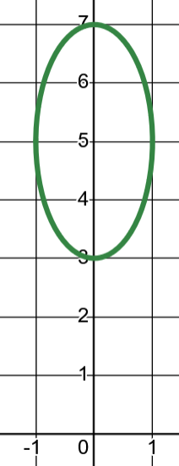
Circular motion.
a). Sketch the path and motion defined by $x\left(t\right)=cos\left(π+t\right)$ and $y\left(t\right)=5+2\sin\left(π+t\right)$.
Show where $t=0$ is and draw arrows indicating the direction of motion.

b). What if we modify part a to be: $x\left(t\right)=cos\left(\frac{π}{t}\right)$ and $y\left(t\right)=5+2\sin\left(\frac{π}{t}\right)$ with the restriction that $t≥1$.
What can you say about the movement? At t = 1, the point is at $(-1, 5)$ and as t increases the point moves clockwise around the circle towards an angle of 0, but never reaching it (it’s decelerating as it approaches an angle of 0).
b). Define an x(t) and y(t) so a point moves clockwise around a circle radius 3 centered at the point (-3, 4).
At t = 0 it should be at (-3, 7). At t = 3 it should be at (-3, 1).
Without worrying about the angle info, I know the overall path will look like: $x\left(t\right)=3cos\left(??\right)-3$ and $y\left(t\right)=3sin\left(??\right)+4$
Make a small sketch to see what angle the point is at when t = 0 and t = 3. At t = 0 the angle is facing straight up (angle of $π$). At t = 3 the angle is facing straight down (angle of $-π$ or $\frac{3π}{2}$). The problem doesn’t specify whether we should rotate clockwise or counter-clockwise, so let’s start at $π$ and rotate counter-clockwise to get to $\frac{3π}{2}$. We can make a linear $A(t)$ function that looks like this:
$A\left(t\right)=\frac{π}{3}t+\frac{π}{2}$ . Putting this together with the path info we get:

$$x\left(t\right)=3\cos\left(\frac{π}{3}t+\frac{π}{2}\right)-3$$
$y\left(t\right)=3\sin\left(\frac{π}{3}t+\frac{π}{2}\right)+4$

Create your own parameterizations.
Create an x(t), y(t) parameterization for $y=x^{2}-2$ where the point moves from right to left as time increases.  $x\left(t\right)=3- t$ will do it.  So $y\left(t\right)={\left(3-t\right)}^{2}-2$ | Create an x(t) and y(t) so that a point moves along the curve  $y=1+\sqrt[3]{x-2}$. At t = 0, its x-coordinate should be -10. By t = 5 it should be further than a distance of 20 from the origin.  By t = 5 I want it to be very far from the origin, so I’ll say at t = 5 it has an x-coordinate of 20. Since the y-coordinate will be positive, I know the overall distance will be larger than 20.  A possible $x(t)$ could be $x\left(t\right)=-10+6t$ so that it hits the x-coordinates I want.  Therefore $y\left(t\right)=1+\sqrt[3]{\left(-10+6t\right)-2}$ or $y\left(t\right)=1+\sqrt[3]{-12+6t}$

